Chicken Boneless

**Chicken Boneless** is a fast-paced arcade shooter in the endless runner genre, where players aim to achieve the highest score possible. Upon loading the game, players are greeted by the main menu, which offers options to view high scores, read the game instructions, or jump straight into the action.

When the game begins, players take control of a chicken that can move freely in eight directions: up, down, left, right, and diagonally (up-left, up-right, down-left, down-right). The chicken starts at the center of the screen, while various enemies spawn and begin to chase.

There are three types of enemies in the game: dogs, cats, and humans. Dogs and cats move at varying speeds and in random directions, while humans move more slowly but deliberately target the chicken's position, making them a persistent threat.

The chicken is armed with a bone, which can be fired to defeat enemies and earn points. Defeating human enemies rewards the player with a special "spin-bone" power-up. Once collected, the spin-bone grants double points for the next 5 seconds, increasing the intensity of the gameplay.

The game is designed to be endless, challenging players to dodge enemies using their full range of movement and skillfully eliminate threats with the bone weapon. The objective is to survive as long as possible and rack up a high score.

If an enemy manages to catch the chicken, the game ends, and the chicken humorously transforms into "Chicken Boneless."

Author: Teerapath Keawratana

Date: 15/01/2025

Copyright Information

**Document Revision History:**

|  |  |  |  |
| --- | --- | --- | --- |
| Version | Date | Author(s) | Changes |
| 1 | January 15, 2025 | Teerapath Keawratana |  |
| 2 | February 14, 2025 | Teerapath Keawratana | 1. Character of chicken, cat, and human.  2. Background picture in Game.  3. The cut Scene. |
| 3 | April 11, 2025 | Teerapath Keawratana |  |

Table of Contents

1. Section I - Game Overview 7

1.1. Game Concept 7

1.2. Design History 7

1.3. Feature Set 7

1.4. Genre 7

1.5. Target Audience 7

1.6. Game Flow Summary 7

1.7. Look and Feel 7

1.8. Project Scope 7

1.8.1. Number of locations 7

1.8.2. Number of levels 7

1.8.3. Number of NPC’s 7

1.8.4. Number of weapons 7

1.8.5. Etc. 7

2. Section II - Gameplay and Mechanics 7

2.1. Gameplay 7

2.1.1. Game Progression 7

2.1.2. Mission/challenge Structure 7

2.1.3. Puzzle Structure 8

2.1.4. Objectives – What are the objectives of the game? 8

2.1.5. Play Flow – How does the game flow for the game player 8

2.2. Mechanics 8

2.2.1. Physics 8

2.2.2. Movement 8

2.2.3. Objects 8

2.2.4. Actions 8

2.2.5. Combat 8

2.2.6. Economy 8

2.3. Screen Flow 8

2.3.1. Screen Flow Chart 8

2.3.2. Screen Descriptions 8

2.4. Game Options 9

2.5. Replaying and Saving 9

2.6. Cheats and Easter Eggs 9

3. Section III – Story, Setting and Character 9

3.1. Story and Narrative 9

3.1.1. Back story 9

3.1.2. Plot Elements 9

3.1.3. Game Progression 9

3.1.4. License Considerations 9

3.1.5. Cut Scenes 9

3.2. Game World 9

3.2.1. General look and feel of world 9

3.2.2. Area #1 10

3.2.3. Area #2 10

3.3. Characters 10

3.3.1. Character #1 10

3.3.2. Character #2 10

4. Section IV – Levels 10

4.1. Level #1 10

4.1.1. Synopsis 10

4.1.2. Introductory Material (Cut scene? Mission briefing?) 10

4.1.3. Objectives 10

4.1.4. Physical Description 11

4.1.5. Map 11

4.1.6. Critical Path 11

4.1.7. Encounters 11

4.1.8. Level Walkthrough 11

4.1.9. Closing Material 11

4.2. Level #2 11

4.3. Training Level 11

5. Section V - Interface 11

5.1. Visual System 11

5.1.1. HUD - What controls 11

5.1.2. Menus 11

5.1.3. Rendering System 11

5.1.4. Camera 11

5.1.5. Lighting Models 11

5.2. Control System 11

5.3. Audio 11

5.4. Music 11

5.5. Sound Effects 11

5.6. Help System 11

6. Section VI - Artificial Intelligence 11

6.1. Opponent AI 11

6.2. Enemy AI 12

6.3. Non-combat Characters 12

6.4. Friendly Characters 12

6.5. Support AI 12

6.5.1. Player and Collision Detection 12

6.5.2. Pathfinding 12

7. Section VII – Technical 12

7.1. Target Hardware and operating system 12

7.2. Supported game controllers and peripherals 12

8. Section VIII – Game Art 12

8.1. Concept Art 12

8.2. Style Guides 12

8.3. Characters 12

8.4. Environments 12

8.5. Equipment 12

8.6. Cut scenes 12

8.7. Miscellaneous 12

# Section I - Game Overview

## Game Concept

The concept of this game is from a restaurant that has a promotion for All-you-can-eat Chicken Boneless, many customers would like to eat Chicken Boneless. That would be an idea to create this game with the main actor as chickens have to escape from all enemies (dogs, cats, and humans). The chicken's weapon is bone, which is thrown to eliminate the enemy. When the chicken was caught, it would turn to be chicken boneless, and the game would end.

The chicken boneless game makes the player emotional because the chicken boneless game has a high score record, which makes players want to keep their name on the top of the recording and makes them always keep breaking the record, or if the other player can break their high score, it makes the player want to bring that position back.

## Design History

Design background of menu scene, leaderboard background scene, and gaming background scene.

Design characters of the chicken, bone, dog, cat, and human.

### Background Design

* **Menu Scene**

A cheerful farm setting with bright, cartoonish aesthetics. The background includes:

* + A blue sky with fluffy clouds.
  + A green field with a tree, bushes, and a winding dirt path.
  + A barn (red color) symbolizing the main gameplay area.
  + A windmill and picket fence enhance the rural farm vibe.
* **Leaderboard Background Scene**

A lush green grassy field creates a fresh and lively atmosphere.

* **Gaming Background Scene**

A lush green grassy field creates a fresh and lively atmosphere.

### Character Design

* **Chicken (Player)**
  + Cute cartoon-style chicken with a slightly rounded body.
  + Expressive eyes for reactions (normal, scared, victorious).
  + Feathers flutter while moving, with slight bounce animation for idle state.
  + When caught, it transforms into a "Chicken Boneless" with animation.
* **Bone (Weapon)**
  + Cartoon-style bone with light shading.
  + When shot, spins while flying.
* **Dog (Enemy)**
  + Medium-sized farm dog with a playful but slightly aggressive look.
  + Fast run animation.
  + Color palette: Brown and white patches.
* **Cat (Enemy)**
  + Sleek, mischievous cat with sharp eyes.
  + Agile running animation.
  + Color palette: Yellow.
* **Human (Enemy)**
  + Cartoon restaurant owner character.
  + Slow but steady run animation focused directly on the chicken.
  + Slightly exaggerated angry expression for humor.

## Feature Set

The high score tracking is one of the features set in the game to make players feel more attracted and challenge them to keep their name on the leaderboard.

## Genre

Arcade, Shooting game.

## Target Audience

Casual Gamer, Competitive Players.

## Game Flow Summary

The player can control a chicken by using the arrow on the keyboard or ASWD to control left, down, up, and right. Use a mouse to shoot the bone to the enemy.

## Look and Feel

The game is a 2D game, making the background of the game in the restaurant, and the player feels like the chicken is running away in the restaurant and doesn’t want to be a boneless chicken.

## Project Scope

The chicken boneless game is a 2D shooting arcade game with a high-score leaderboard.

### Number of locations

One location is the farm behind a restaurant.

### 

### Number of levels

There is no level exactly, but when players play the games longer, the games will spawn more enemy

### Number of NPC’s

There are three Non-Playable Characters.

The dogs will run in-game at a normal speed but with no direction.

The cats will run in-game faster than the dogs with no direction.

The humans will run at the slowest speed with a direction focused on the chicken.

### Number of weapons

One weapon that the chicken uses to destroy an enemy is chicken bone.

### Etc.

# Section II - Gameplay and Mechanics

## Gameplay

### Game Progression

When the game starts, the player controls a chicken to escape from an enemy (dogs, cats, and humans). Then, the player can shoot bones to destroy an enemy and collect a score. The game will spawn more energy when the player gets a higher score.

### Mission/challenge Structure

The game's mission is for the player to control a chicken to escape from dogs, cats, and humans that appear in the game. They must shoot them with a chicken bone to collect more scores and keep their name on the leaderboard.

### Objectives – What are the objectives of the game?

Keep chickens safe for as long as possible and earn as much score as possible.

### Play Flow – How does the game flow for the game player

The player can control a chicken in the game to escape an enemy and shoot an enemy to keep a higher score.

## Mechanics

The game operates within strict window boundaries to maintain gameplay clarity. All game entities, including the player, enemies, and projectiles, must always stay within the window frame. When enemy characters like dogs or cats collide with the window edges, they will reflect in the opposite direction while maintaining their speed, creating dynamic movement patterns. However, if the player-controlled chicken hits the edge of the window, its movement will stop immediately at that position, requiring the player to change direction to continue moving.

Players control the chicken character using either the **W, A, S, and D** keys or the arrow keys for directional movement. Attacks are performed by aiming at the mouse and clicking the left mouse button to shoot bone projectiles. To assist with precise aiming, a cross-arrow target is displayed on the screen, allowing the player to clearly see the shooting direction and adjust accordingly.

Enemy dogs and cats spawn at random positions within the game window and move unpredictably with random velocities and directions. These enemies follow the same boundary rules, bouncing off the window edges to keep the gameplay space active and engaging. Human enemies also spawn randomly, but their behavior is more advanced. They use a basic AI system to consistently follow and pursue the player’s chicken at a steady speed, adding a layer of challenge and urgency.

When the player successfully eliminates a human enemy, a special power-up called the **Spin-Bone** appears at the defeated enemy’s location. Collecting this power-up grants the player double points for each enemy defeated within the next five seconds, encouraging aggressive and strategic play during this time-limited bonus period.

The aiming system is enhanced by the cross-arrow target, which visually indicates the direction of the player’s shots. Players can move this target with the mouse to adjust their aim and precisely direct their bone projectiles at the incoming enemies.

### Physics

The game implements simple yet effective physics to ensure responsive and predictable interactions between all game elements. Enemy characters such as dogs, cats, and humans are programmed to move at a constant speed. While their velocity remains unchanged, their movement direction is influenced by collisions with the boundaries of the game window. When an enemy collides with the edge of the window, it instantly reflects its direction to the exact opposite side while maintaining its original speed. This creates continuous and dynamic movement across the play area, keeping the action lively.

For the aiming and shooting system, vector normalization is applied to the direction of the crosshair target. This ensures that the player’s shooting direction remains accurate and consistent, regardless of the position of the crosshair on the screen. By normalizing the vector, the length of the direction vector is fixed, preventing excessive or infinite range of projectile travel. This allows for fair and predictable bone projectile behavior, giving the player clear control over their shots while maintaining balanced gameplay mechanics.

### Movement

#### General Movement

The player can use an arrow on the keyboard to move or use A-left, S-down, E-up, and D-right. And use the mouse to click left to shoot the bone weapon.

#### Other Movement

The dog and cat will move at a constant speed in a random direction. The human will move slower, but the direction follows the chicken.

## Screen Flow

### Screen Flow Chart

Main Menu Screen

Instruction Screen

Leaderboard Screen

High Score Input Screen

Game Screen

High score?

### Screen Descriptions

The Main Menu Screen allows the player to choose to see the leaderboard screen or start the game on the game screen. If the player goes to the leaderboard Screen, they can only return to the Main Menu Screen.

When the player goes to play the game on the Game Screen and loses the game without reaching a high score, the game screen will return to the Main Menu Screen. But if the score reached a high score, the High Score Input Screen would appear to make the player input their name. After the player finishes inputting the name, it will go to the Leaderboard Screen and back to the Main Menu Screen again.

#### Main Menu Screen

The Main Menu Screen is like the home screen that the player must return to every time after playing or watching the leaderboard.

#### Options Screen

The Game Screen is the scene where the player plays the game and has fun with the chicken boneless game.

The High Score Input would be shown to the player only when the player finished the game with a high score.

The Leaderboard Screen is used to show the player to watch the high score ranking and only go back to the Main Menu Screen.

The Instruction Screen is used to show the player how to control the chicken and how to play the game.

## Game Options

## Replaying and Saving

## Cheats and Easter Eggs

# Section III – Story, Setting and Character

## Story and Narrative

Specific details like scripts and cut scenes may not be in this document but be in the Story Bible.

### Back story

Start at the restaurant that cooks boneless chicken but has one lucky chicken trying to escape from that restaurant but is still stuck in the green field behind the restaurant. It’s trying to run away from dogs, cats, and humans, and they are trying to catch it.

### Plot Elements

### Game Progression

When the player plays the game longer, the game will make more enemies on the screen to challenge the player.

### License Considerations

The background picture of the Game, Main Menu, and Leaderboard Screen. The Sprite of a chicken, dog, cat, and human are license considerations.

### Cut Scenes

#### Cut scene #1

At loading the game, in the Main Menu Screen

##### Actors

A Chicken

##### Description

A Chicken smiling and happy like it already escaped from the restaurant.

##### Storyboard

A chicken had already run away from the kitchen at the restaurant and thought it was safe, but unfortunately, it was still in the dining room, so the chicken had to run away again.

##### Script

#### Cut scene #2

At the end of the game, after a chicken was caught.

##### Actors

A chicken

##### Description

A chicken was caught and turned into a chicken boneless.

##### 3.1.5.2.3 Storyboard

At the end of the game, the chicken is caught by the enemy and turned into a chicken boneless in the restaurant.

## Game World

### General look and feel of world

### Area #1

The background of the game screen

#### General Description

The background of the game screen is in the farm field behind the restaurant.

#### Physical Characteristics

The lush green grassy field creates a fresh and lively atmosphere.

#### Levels that use area

#### Connections to other areas

### Area #2

etc.

## Characters

### Character #1

Chicken

#### Back story

A chicken ran away from the kitchen at the green field behind the restaurant, thinking it was safe, but unfortunately, it was still in the dining room.

#### Personality

A happy chicken, but easy to panic.

#### Look

##### Physical characteristics

##### Animations

#### Special Abilities

A chicken can use bone as a weapon.

#### Relevance to game story

The main actor in the game.

#### Relationship to other characters

#### Statistics

### 

### Character #2

A dog in the dining room

#### Back story

A dog runs into the green field behind the restaurant because it sees the chicken and wants to eat a boneless chicken.

#### Personality

Hungry dog, running without direction

#### Relevance to game story

The one out of three enemies of the chicken.

### Character#3

A cat in the dining room.

#### Back story

A cat runs into the green field behind the restaurant because it sees the chicken and wants to eat a boneless chicken.

#### Personality

Hungry cat, running without direction.

#### Relevance to game story

Another enemy of a chicken ran faster than a dog, but still no direction.

### Character#4

A Human, the dangerous enemy of the chicken, runs slowest, but the direction focuses on the chicken.

#### Back story

The restaurant owner saw the chicken run into the green field behind the restaurant, and he wanted to catch the chicken back in the kitchen.

#### Personality

A patient restaurant owner.

#### Relevance to game story

The dangerous enemy of a chicken, even though slowest, has a focusing direction on a chicken.

# Section IV – Levels

## Level #1

### Synopsis

### Introductory Material (Cut scene? Mission briefing?)

### Objectives

### Physical Description

### Map

### Critical Path

### Encounters

### Level Walkthrough

### Closing Material

## Level #2

etc.

## Training Level

# Section V - Interface

## Visual System

### HUD - What controls

### Menus

### Rendering System

### Camera

### Lighting Models

## Control System

How does the game player control the game? What are the specific commands?

## Audio

Die sound when a chicken is caught and turns to be boneless.

## Music

Exciting music during game running.

## Sound Effects

When a chicken shoots bone at the enemy, there is a collision between the chicken and the enemy.

## Help System

# Section VI - Artificial Intelligence

## Enemy AI

Humans' direction focuses on a chicken.

# Section VII – Technical

## Target Hardware and operating system

Windows 11

## Supported game controllers and peripherals

# Section VIII – Game Art

Only show concept art here (rough sketches)

## Concept Art

## Style Guides

## Characters

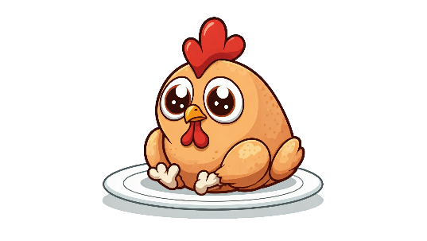



The Chicken boneless The chicken The human



The dog The cat

## Environments

The vibrant green background provides a sense of freshness and positivity, in the top view.



## Equipment

## Cut scenes

The Chicken throws a bone at a cat scene.

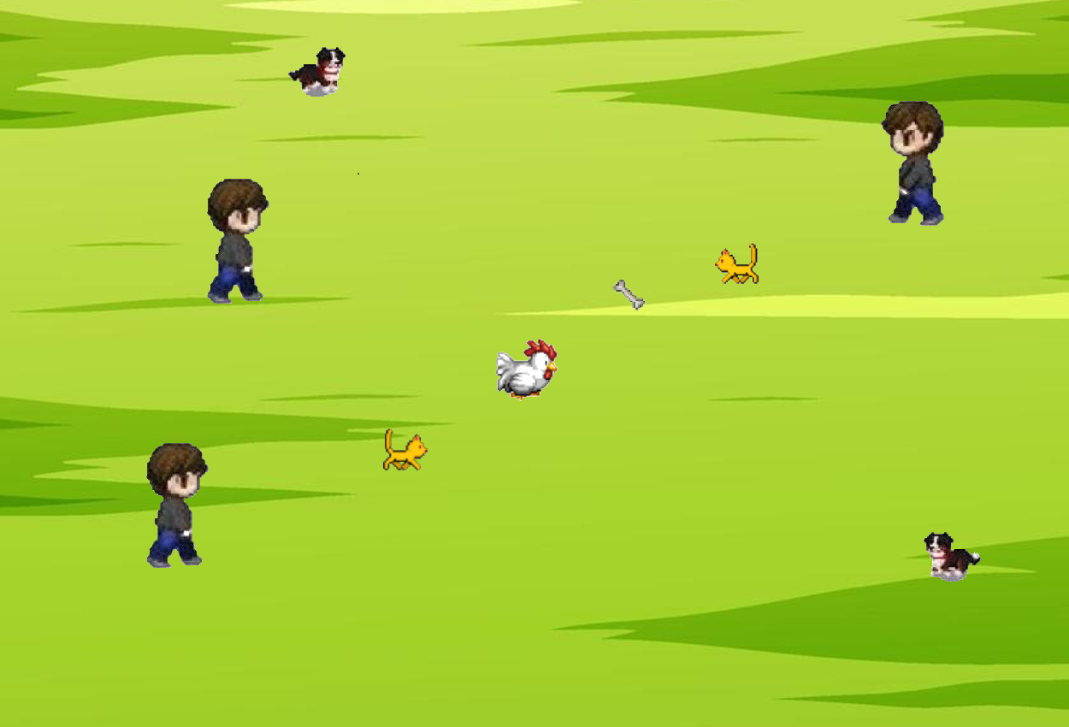

## Miscellaneous